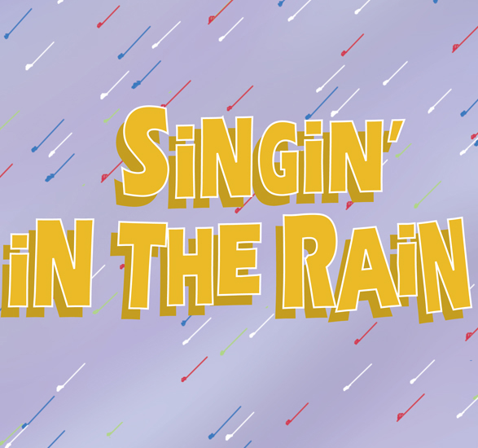
JANUARY 2018

Sunday | Monday | Tuesday | Wednesday | Thursday | Friday | Saturday
 | 1 | 2 | 3 | 4 | 5 | 6
 |  |  |  | Classes Resume  Don, Cosmo, Kathy  5 – 6:15 | Tap Girls -3:15 – 3:45  3:45 – 5:00 – Dora, Don, Cosmo, RF, Lina, Rod, Kathy
7 | 8 | CHOREOGRAPHY 9 | 10 | 11 | 12 | 13
 | 5 – 6:15 pm – Classroom  Don and Katy | Tap Girls – 5 – 6:15  Beautiful Girls and Nick – 6:15 - 7 |  | Act I, Scenes 1-3  5 – 6:30  Passersby, Don, Kathy | 3:15 – 4  Cosmo, Don | 1 pm – 3 pm  Don, Kathy, Cosmo, Lina  (Zelda 1pm – 2 pm)
14 | 15 | 16 | 17 | 18 | 19 | 20
 | Martin Luther King Day  No School | Broadway Melody  5 – 6:15  Tap Girls – 5 - 7 |  | Act 1, Scenes 4-5  5 – 6:30 pm  Don, Kathy, Passersby, Tap, Lina, Cosmo, RF, Dexter | 3:15 – 4:00  Miss Dinsmore, Male Dicton Coach, Lina, Don, Cosmo | (Junior Seminar 8 am)  Main Characters 1 - 4
21 | 22 | 23 | 24 | Act I, Scene 1 – 5 25 | 26 | 27
 | 5 – 6:30 pm  The Royal Rascal – Don, Lina, Gaspard, Henchmen | Good Morning – 5 – 7  Broadway Melody 5 – 6:15 |  | 5 pm – 7 pm – Stars, Lina, Cosmo, Girl, Don, RF, Rod, Dexter, Butler, Photographer, Kathy, Passersby | 3:15 – 4 pm  Don, Cosmo, Kathy | 2 pm – 6 pm  Filming sequences
28 | 29 | 30 | 31 | Broadway Melody  Chelsea, Madelyn, Leigh, Jenna, Caleb, Olivia, Violette, Ashley, Tori, John, Ashlynn, JD, Lexie,  Ethan, McKenna, Seth, Ellie, , Channing, Carter | Broadway Melody  Sydney, Kelsa, Madison, Kade, Meg, Ryan, Alex, Chinaja, Ijeoma, Ike, Ethan, Ian, Connor | Passersby/Audience  Leigh, Madelyn, Caleb, Olivia, Gab, John, Sadie, JD, Lili, Meg, Ryan, Bailee, Esosa, Ethan, Ian, Seth, Abby, Nick

